**D.A.V. PUBLIC SCHOOL**

**AUNDH, PUNE**

IP PROJECT FILE

(2018-19)

**D.A.V ELECTION SOFTWARE**

Acknowledgement

I would like to thank our IP teacher Ms. Geetanjali ma’am for her guidance and providing me with all the help I needed for the completion of the project. I am also thankful to her for allowing me to use the lab whenever required.

I would also like to thank my classmates for their timely inputs and technical support.

I also extend my thankfulness to our principal ma’am Mrs C.V.Madhavi for the encouragement, motivation and the necessary infrastructure for the successful completion of this project-

“ *D.A.V Election Software* ”

INDEX

1. STRUCTURE
2. JAVA SCREENSHOTS & CODING
3. DATABASE (MySQL)
4. BIBLIOGRAPHY
5. CD OF THE PROJECT

JAVA CODE & SCREENSHOTS

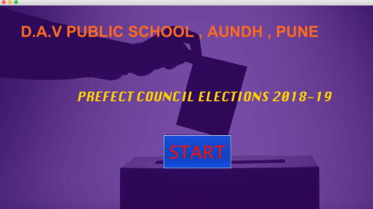

|  |
| --- |
| H:\screenshotsForFile\Screen Shot 2018-12-03 at 5.06.01 PM.pngH:\screenshotsForFile\Screen Shot 2018-12-03 at 5.05.38 PM.pngH:\screenshotsForFile\Screen Shot 2018-12-03 at 5.06.20 PM.pngH:\screenshotsForFile\Screen Shot 2018-12-03 at 5.05.13 PM.png |

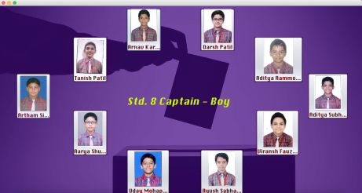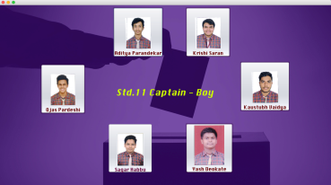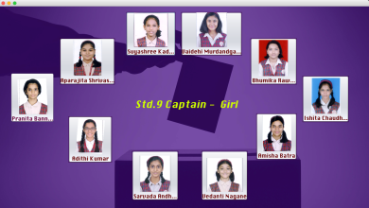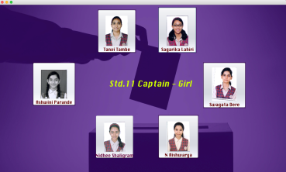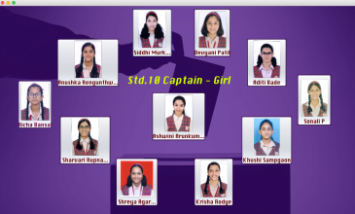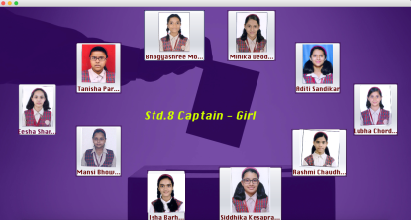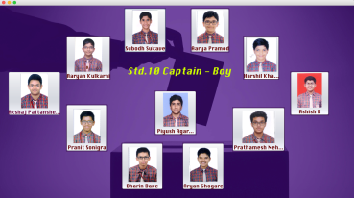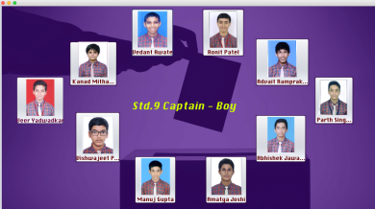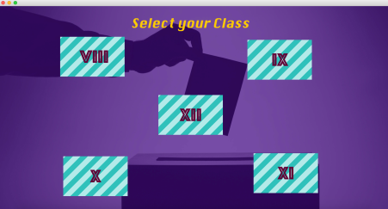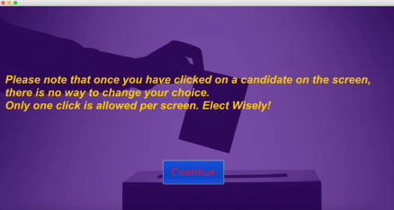

The program is controlled mainly by a custom designed class, named as controller.

package controlSet;

import java.sql.DriverManager;

import java.sql.Connection;

import java.sql.Statement;

import javax.swing.JOptionPane;

public class controller {

public static int i = 0, j = 0;

public static void classSelect(int standard){

switch(standard){

case 8: classEight(); break;

case 9: classNine(); break;

case 10: classTen(); break;

case 11: classEleven(); break;

case 12: classTwelve(); break;

}

}

public static void commonScreens(){

switch(j){

case 0: new std12.headboy().setVisible(true); break;

case 1: new std12.headgirl().setVisible(true); break;

case 2: new std12.sportscaptainboy().setVisible(true); break;

case 3: new std12.sportscaptaingirl().setVisible(true); break;

case 4: new controlSet.endPage().setVisible(true); break;

}

}

public static void classEight(){

switch(i){

case 0: new std8.std8captainboy().setVisible(true); break;

case 1: new std8.std8captaingirl().setVisible(true); break;

case 2: commonScreens(); break;

}

}

public static void classNine(){

switch(i){

case 0: new std9.std9captainboy().setVisible(true); break;

case 1: new std9.std9captaingirl().setVisible(true); break;

case 2: commonScreens(); break;

}

}

public static void classTen(){

switch(i){

case 0: new std10.std10captainboy().setVisible(true); break;

case 1: new std10.std10captaingirl().setVisible(true); break;

case 2: commonScreens();

}

}

public static void classEleven(){

switch(i){

case 0: new std11.std11captainboy().setVisible(true); break;

case 1: new std11.std11captaingirl().setVisible(true); break;

case 2: commonScreens();

}

}

public static void classTwelve(){

commonScreens();

}

public static void resetVariables(){

int n = 0;

if(i != 0 && j != 0){n = 6;}

else if(i == 0 && j != 0){n = 4;}

System.out.println(n);

try{

Class.forName("java.sql.Driver");

Connection con = DriverManager.getConnection("jdbc:mysql://192.168.1.34/dav","root","1234");

String query = "update total set totalVotes = totalVotes + " + n + ";";

Statement stm = con.createStatement();

stm.executeUpdate(query);

stm.close();

con.close();

}

catch(Exception e){

JOptionPane.showMessageDialog(null,e.getMessage());

}

i = 0; j = 0;

}

}

The First Page



import java.sql.DriverManager;

import java.sql.Connection;

import java.sql.Statement;

import java.sql.ResultSet;

import javax.swing.JOptionPane;

public class startPage extends javax.swing.JFrame {

public startPage() {

initComponents();

this.setExtendedState(JFrame.MAXIMIZED_BOTH);

}

private void jButton1ActionPerformed(java.awt.event.ActionEvent evt) {

new disclaimer().setVisible(true);

this.dispose();

try{

Class.forName("java.sql.Driver");

Connection con = DriverManager.getConnection("jdbc:mysql://192.168.1.34/dav","root","1234");

String query = "select * from total;";

Statement stm = con.createStatement();

ResultSet rs = stm.executeQuery(query);

rs.close();

stm.close();

con.close();

}

catch(Exception e){

JOptionPane.showMessageDialog(null,e.getMessage());

}

}

This page is inserted in between to make voters aware of the working of the system.

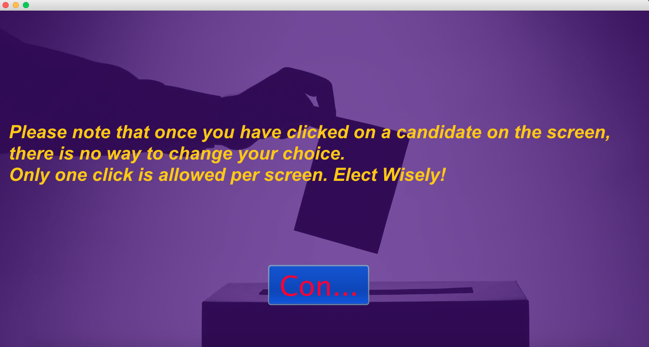

package controlSet;

import javax.swing.JFrame;

public class disclaimer extends javax.swing.JFrame {

    public disclaimer() {

        initComponents();

        this.setExtendedState(JFrame.MAXIMIZED_BOTH);

    }

private void jButton1ActionPerformed(java.awt.event.ActionEvent evt) {                                         

        this.dispose();

        new stdselect().setVisible(true);

    }

    private javax.swing.JLabel background;

    private javax.swing.JButton jButton1;

    private javax.swing.JLabel jLabel1;

}

This page is for the voters to select their standard to vote in the appropriate category.

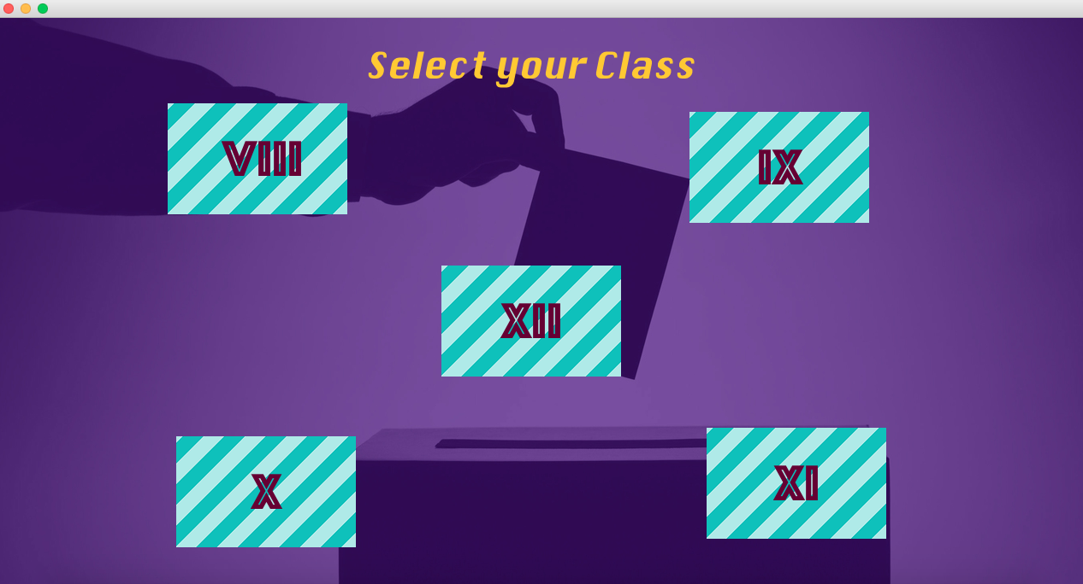

If the student is not from std 12, the program takes the student to the voting pages of their corresponding standard, to vote for the Standard Captains (Boy and Girl), and then to vote for the Head Boy, Head Girl, and the Sports Captains (Boy and Girl).

If the student is in STD 12, he/she is automatically taken to the screen to vote for Headboy, Headgirl and the Sports Captains.

package controlSet;

import javax.swing.JFrame;

import javax.swing.JOptionPane;

public class stdselect extends javax.swing.JFrame {

    public stdselect() {

        initComponents();

        this.setExtendedState(JFrame.MAXIMIZED_BOTH);

  }

private void commonMethod(java.awt.event.ActionEvent evt) {

        this.dispose();

        controller.classSelect(Integer.parseInt(evt.getActionCommand()));

    }

private javax.swing.JLabel background;

    private javax.swing.JButton class10btn;

    private javax.swing.JButton class11btn;

    private javax.swing.JButton class12btn;

    private javax.swing.JButton class8btn;

    private javax.swing.JButton class9btn;

    private javax.swing.JLabel jLabel1;

}

The coding for most of the voting frames is same, since frame transition is controlled by the controller class, and the code for casting the vote is not different.

The Head Boy

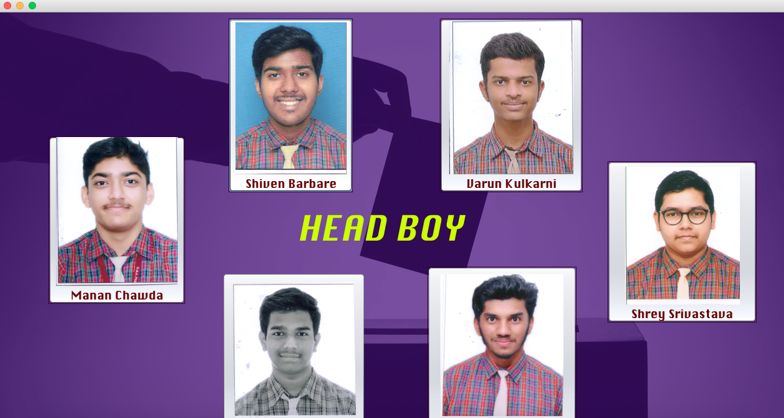

package std12;

import controlSet.controller;

import javax.swing.JFrame;

import java.sql.*;

import javax.swing.JOptionPane;

public class headboy extends javax.swing.JFrame {

    public headboy() {

        initComponents();

        this.setExtendedState(JFrame.MAXIMIZED_BOTH);

    }

void commonMethod(){

        controller.j++;

        controller.commonScreens();

        this.dispose();

    }

    private void vote(java.awt.event.ActionEvent evt) {

        commonMethod();

        try{

            Class.forName("java.sql.Driver");

            Connection conn = DriverManager.getConnection("jdbc:mysql://192.168.1.34/dav", "root","1234");

            String candidate = evt.getActionCommand();

            String query = "update headboy set votes = votes + 1 where name='" + candidate + "';";

            Statement st = conn.createStatement();

            st.executeUpdate(query);

            st.close();

            conn.close();

        }

        catch(Exception e){

            JOptionPane.showMessageDialog(rootPane, e.getMessage());

        }

    }

    private javax.swing.JLabel background;

    private javax.swing.JButton jButton1;

    private javax.swing.JButton jButton2;

    private javax.swing.JButton jButton3;

    private javax.swing.JButton jButton4;

    private javax.swing.JButton jButton5;

    private javax.swing.JButton jButton6;

    private javax.swing.JLabel jLabel1;

}

Similar code is written for the Head Girl frame.

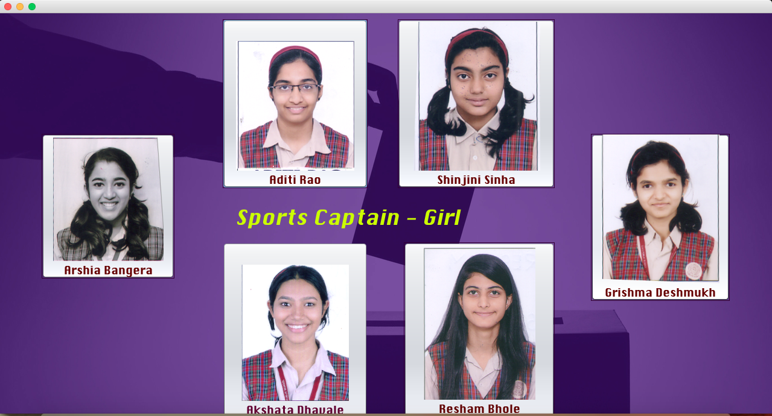Sports Captain - Girl

package std12;

import controlSet.controller;

import javax.swing.JFrame;

import java.sql.*;

import javax.swing.JOptionPane;

public class sportscaptaingirl extends javax.swing.JFrame {

    public sportscaptaingirl() {

        initComponents();

        this.setExtendedState(JFrame.MAXIMIZED_BOTH);

    }

void commonMethod(){

        controller.j++;

        controller.commonScreens();

        this.dispose();

    }

private void vote(java.awt.event.ActionEvent evt) {

        commonMethod();

        try{

            Class.forName("java.sql.Driver");

            Connection conn = DriverManager.getConnection("jdbc:mysql://192.168.1.34/dav", "root","1234");

            String candidate = evt.getActionCommand();

            String query = "update sportscaptaingirl set votes = votes + 1 where name='" + candidate + "';";

            //System.out.println(query);

            Statement st = conn.createStatement();

            st.executeUpdate(query);

            st.close();

            conn.close();

        }

        catch(Exception e){

            JOptionPane.showMessageDialog(rootPane, e.getMessage());

        }

    }

    private javax.swing.JLabel background;

    private javax.swing.JButton jButton1;

    private javax.swing.JButton jButton2;

    private javax.swing.JButton jButton3;

    private javax.swing.JButton jButton4;

    private javax.swing.JButton jButton5;

    private javax.swing.JButton jButton6;

    private javax.swing.JLabel jLabel1;

}

Similar code is written for the Sports Captain - Boy Frame and for all other frames of other standards.

And the final page

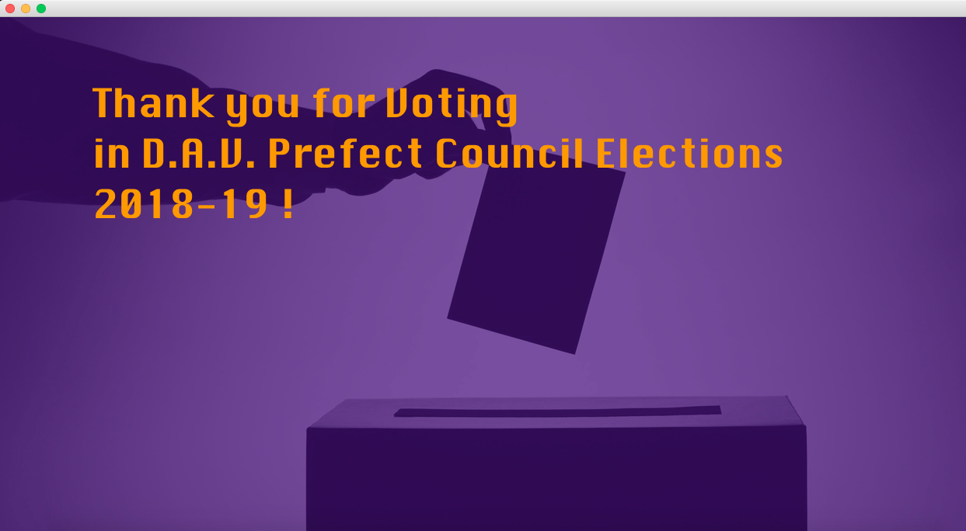

package controlSet;

import javax.swing.JFrame;

public class endPage extends javax.swing.JFrame {

    public endPage() {

        initComponents();

        this.setExtendedState(JFrame.MAXIMIZED_BOTH);

    }

private void formKeyReleased(java.awt.event.KeyEvent evt) {

        System.out.println("hello");

        if(evt.getKeyCode() == 86){

            new startPage().setVisible(true);

            controller.resetVariables();

            this.dispose();

        }

    }

 private javax.swing.JLabel background;  
 private javax.swing.JLabel jLabel1;

}

Here is a small piece of code that provides security against some unruly voters who might have tried to vote twice. The next round of voting on a machine can only be resumed by pressing the key ‘V’ at the end page ☺

DATABASE PART

(MySQL)

The database consists of twelve tables, one for each category of post, (Head Boy, Head Girl, Sports Captains [Boy and Girl], Standard Captains [Boy and Girl]).

Database connectivity to MySQL, through Java is accomplished through the JDBC(Java Database Connectivity). The JDBC connects to a MySQL server through an existing user account which has the permissions to access the database.

Hence for multiple computers to interact with a database stored on a separate computer, various MySQL accounts were created, one for each connection between a host and the server.

Procedure to create the new accounts is as follows:

1. In your host computer, open MySQL and type in > create user ‘abc’@’serverip’ identified by ‘passd’;
2. Next type in > grant all previliges on *.* to ‘abc’@’localhost’;
3. On the server computer, on mysql type in > create user ‘abc’@’hostip’ identified by ‘passd’;
4. Next type in > grant all previliges on *.* to ‘abc’@’hostip’;

‘hostip’ is the ip address of the host machine and the ‘serverip’ is the ip address of the server machine.

Restarting both the machines once should get the connection running.

The database after the completed session of voting:

**Head Boy**

**+------------------+-------+**

**| Name | votes |**

**+------------------+-------+**

**| Parth Ankam | 580 |**

**| Shiven Barbare | 330 |**

**| Varun Kulkarni | 100 |**

**| Manan Chawda | 78 |**

**| Shrey Srivastava | 49 |**

**| Aditya Rege | 42 |**

**+------------------+-------+**

**Head Girl**

**+--------------------+-------+**

**| Name | votes |**

**+--------------------+-------+**

**| Sonia Pandit | 559 |**

**| Prutha Gurme | 252 |**

**| Astha Jain | 143 |**

**| Srinidhi Ramprasad | 121 |**

**| Mrinmayee Mahajan | 76 |**

**| Isha Sonekar | 28 |**

**+--------------------+-------+**

**Sports Captain Boy**

**+----------------+-------+**

**| Name | votes |**

**+----------------+-------+**

**| Sahil Deshmukh | 573 |**

**| Jayesh Murkute | 445 |**

**| Inder Singh | 66 |**

**| Saurabh Sangam | 54 |**

**| Hersh Kumar | 30 |**

**| Suraj Shelke | 11 |**

**+----------------+-------+**

**Sports Captain Girl**

**+------------------+-------+**

**| Name | votes |**

**+------------------+-------+**

**| Resham Bhole | 309 |**

**| Arshia Bangera | 270 |**

**| Grishma Deshmukh | 246 |**

**| Akshata Dhavale | 137 |**

**| Aditi Rao | 128 |**

**| Shinjini Sinha | 89 |**

**+------------------+-------+**

**Std 8 Captain Boy**

**+-----------------+-------+**

**| Name | votes |**

**+-----------------+-------+**

**| Viransh Fauzdar | 71 |**

**| Aditya Subhash | 65 |**

**| Aarya Shukla | 36 |**

**| Uday Mohapatra | 35 |**

**| Darsh Patil | 31 |**

**| Ayush Sabhasad | 26 |**

**| Arnav Karole | 21 |**

**| Aditya Rammohan | 20 |**

**| Tanish Patil | 16 |**

**| Artham Sinha | 11 |**

**+-----------------+-------+**

**Std 8 Captain Girl**

**+----------------------+-------+**

**| Name | votes |**

**+----------------------+-------+**

**| Lubha Chordiya | 62 |**

**| Mansi Bhowmik | 44 |**

**| Bhagyashree Mohan | 37 |**

**| Aditi Sandikar | 37 |**

**| Siddhika Kesapragada | 33 |**

**| Isha Barhate | 28 |**

**| Mihika Deodhar | 26 |**

**| Rashmi Chaudhary | 25 |**

**| Eesha Sharat | 25 |**

**| Tanisha Parmar | 15 |**

**+----------------------+-------+**

**Std 9 Captain Boy**

**+-------------------+-------+**

**| Name | votes |**

**+-------------------+-------+**

**| Manuj Gupta | 53 |**

**| Amatya Joshi | 49 |**

**| Advait Ramprakash | 44 |**

**| Parth Singhal | 41 |**

**| Ronit Patel | 21 |**

**| Vishwajeet Pise | 21 |**

**| Vedant Awate | 17 |**

**| Veer Yadwadkar | 13 |**

**| Kanad Mithawala | 12 |**

**| Abhishek Jawalkar | 10 |**

**+-------------------+-------+**

**Std 9 Captain Girl**

**+-----------------------+-------+**

**| Name | votes |**

**+-----------------------+-------+**

**| Adithi Kumar | 98 |**

**| Vaidehi Murdandgauda | 37 |**

**| Vedanti Nagane | 27 |**

**| Suyashree Kadam | 27 |**

**| Ishita Chaudhary | 24 |**

**| Pranita Banndre | 18 |**

**| Aparajita Shrivastava | 17 |**

**| Sarvada Andhare | 16 |**

**| Amisha Batra | 12 |**

**| Bhumika Rawate | 5 |**

**+-----------------------+-------+**

**Std 10 Captain Boy**

**+---------------------+-------+**

**| Name | votes |**

**+---------------------+-------+**

**| Piyush Agarwal | 107 |**

**| Aaryan Kulkarni | 42 |**

**| Akshaj Pattanshetty | 26 |**

**| Aryan Ghogare | 24 |**

**| Prathamesh Nehete | 23 |**

**| Subodh Sukave | 23 |**

**| Harshil Khara | 21 |**

**| Aarya Pramod | 13 |**

**| Dharin Dave | 11 |**

**| Ashish B | 11 |**

**| Pranit Sonigra | 10 |**

**+---------------------+-------+**

**Std 10 Captain Girl**

**+---------------------+-------+**

**| Name | votes |**

**+---------------------+-------+**

**| Richa Bansal | 105 |**

**| Devyani Patil | 42 |**

**| Sonali P | 28 |**

**| Anushka Rengunthwar | 26 |**

**| Aditi Bade | 21 |**

**| Khushi Sampgaon | 20 |**

**| Sharvari Rupnawar | 17 |**

**| Shreya Agarwal | 17 |**

**| Krisha Rodye | 16 |**

**| Siddhi Murkute | 11 |**

**| Ashwini Arunkumar | 8 |**

**+---------------------+-------+**

**Std 11 Captain Boy**

**+-------------------+-------+**

**| Name | votes |**

**+-------------------+-------+**

**| Aditya Parandekar | 32 |**

**| Krishi Saran | 27 |**

**| Ojas Pardeshi | 23 |**

**| Yash Deokate | 23 |**

**| Kaustubh Vaidya | 12 |**

**| Sagar Habbu | 8 |**

**+-------------------+-------+**

**Std 11 Captain Girl**

**+------------------+-------+**

**| Name | votes |**

**+------------------+-------+**

**| Ashwini Parande | 43 |**

**| Sagarika Lahiri | 28 |**

**| Nidhee Shaligram | 16 |**

**| Swagata Dere | 14 |**

**| N Aishwarya | 13 |**

**| Tanvi Tambe | 11 |**

**+------------------+-------+**

BIBLIOGRAPHY

* TUTORIALSPOINT.COM
* STACKOVERFLOW.COM
* Book by SUMITA ARORA (PART 1 & 2)